2013年 “外研社杯”全国英语写作大赛
决赛样题及评分细则

类型一：记叙文写作（Narrative Writing）
比赛内容：选手完成一篇记叙文写作（600－800词）。侧重考查选手的阅读理解、语言运用、细节描写、形象思维、创意构思、人文素养等综合能力。
评分标准：
Narrative Writing
Content/Ideas  40% | - Theme is strong and well-defined;  - Setting, characters, and plot are fully fleshed out and connected;  - Writing uses multiple subplots (if appropriate);  - Ending is fitting and effective, and provides a sense of completion.
Organization/Development  30% | - Flow of action is logical and deliberate;  - Vivid and imaginative descriptive details are provided;  - Writing reflects a unique, consistent personal voice;  - Writing uses appropriate and varied rhetorical devices.
Language  30% | - Spelling is accurate;  - Word choice is inventive, appropriate, and deliberate for illustrating the topic and presenting character(s);  - Sentence structure is varied and complex, and serves the purpose of writing;  - Dialogue (when present) is believable, appropriate, and effective.

比赛样题：
Sample task 1
Read the story starter and continue the story. Complete the story in 600-800 words.

The little man came up to me as I was about to enter the telephone box, and asked me whether I had a match.
“I’m sorry,” I said. “I don’t smoke, so I haven’t any. You had better ask someone else.”
He looked rather disappointed, hesitated, and then turned away. I watched him walk slowly down the street before I picked up the telephone directory to look up the number I meant to dial.
I am not used to a public call box so, at my first attempt to get through, the warning pips had stopped before I realized I had to insert a coin.
When I was at last able to speak, I was told that the person whom I urgently wanted to give a message to had just that minute gone out.
Swearing slightly under my breath, I emerged from the box and came face to face with the little man, who was looking as pathetic as a stray dog. As he raised his hat again, I could see he was quite bald. A thin line, resembling a duelling scar, crossed one cheek. He spoke nervously.
“Excuse my troubling you again,” he said. “May I walk along with you a little way? I must confide in someone. I need help desperately.”

Sample task 2
Look at the pictures, and write a story that fits the pictures and the sequence. Your story should be 600-800 words.

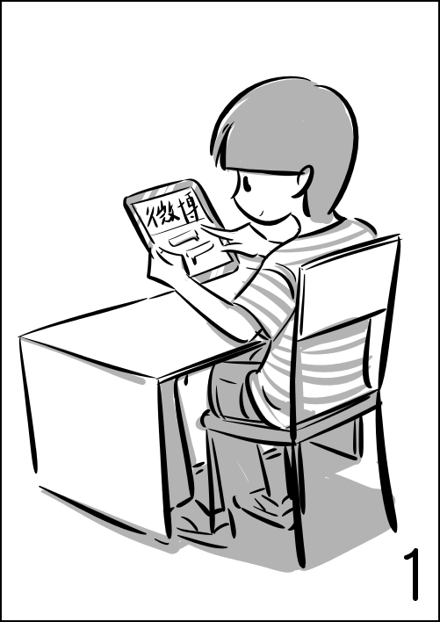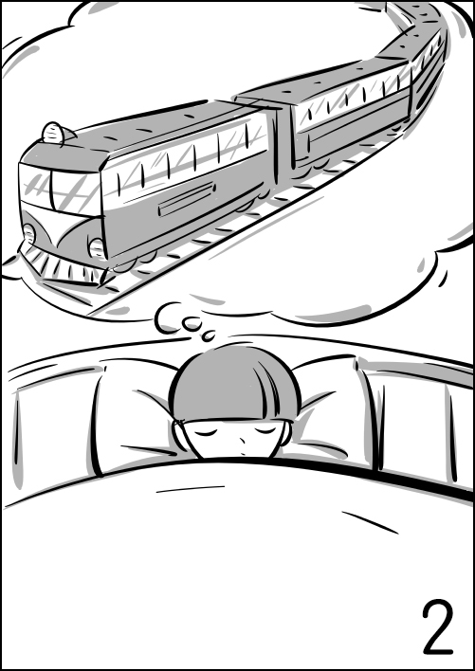
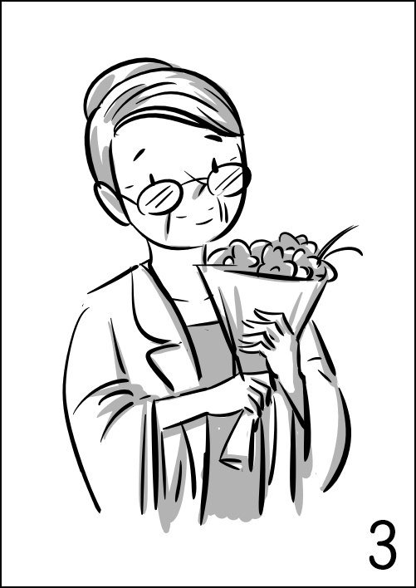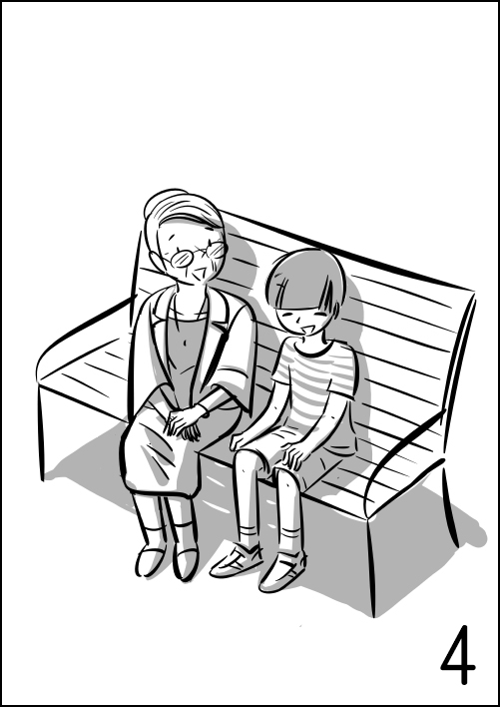

类型二：议论文写作（Argumentative Writing）
比赛内容：选手完成一篇议论文写作（800词左右）。侧重考查选手的文献阅读理解、信息综合处理、判断分析、逻辑思辨、评价论述等能力，展示选手的知识广度、视野维度、思想深度等综合素质。

评分标准：
Argumentative Writing
Content/Ideas  40% | - Writing effectively addresses the topic and the task;  - Writing presents an insightful position on the issue;  - The position is strongly and substantially supported or argued.
Organization/Development  30% | - Writing is well-organized and well-developed, using appropriate rhetorical devices (e.g. exemplifications, classification, analysis, comparison/contrast, etc.) to support the thesis or to illustrate ideas;  - Writing displays coherence, progression, consistency and unity;  - Textual elements are well-connected through explicit logical and/or linguistic transitions.
Language  30% | - Spelling is accurate;  - Writing displays consistent facility in use of language;  - Writing demonstrates appropriate register, syntactic variety, and effective use of vocabulary.

比赛样题：
Sample task 1
Write a passage in response to the report below. You should discuss the extent to which you agree or disagree with the report and explain your reasons for the position you take. In developing and supporting your position, you should consider ways in which the report’s opinion might or might not hold true and explain how these considerations shape your position. You should write about 800 words.

Newsweek, the venerable weekly publication that will be remembered for its decades-long efforts for a spot on consumers’ coffee tables, has shut down its print edition at the end of 2012, but it lives on in a new digital tablet edition known as Newsweek Global. As Tina Brown, the Newsweek editor, said, this tablet edition will target a “new highly mobile, opinion-leading audience who want to learn about world events in a sophisticated context.”
The move should not shock. The publication has faced major financial problems in recent years. The numbers tell the tale: Newsweek’s circulation has fallen in the number of subscribers from 3 million to 1.5 million in the last decade; annual losses were thought to be $40 million. More broadly, the company faces a more existential problem in that a “weekly news” magazine has become an anachronism in the digital world.
Newsweek is not the only one that has to tackle the challenge in the digital time; other outlets will continue to change their business models for a digital future. With the “imminent death” of print, digital formats come out as an inevitable development that could turn the industry’s fortune around.

Sample Task 2
Read the following two paragraphs with contradicting views, and write a passage on the issue. You should clearly state your opinion and explain the reasons for your opinion. You should write about 800 words.

Tablets are the ideal system of organization in schools. They are convenient, in which much information is stored in small sizes and kept together in one place, and cheap, as digital information is now becoming more affordable than print. As evolution continues to rock the modern world, digital devices will become more and more reliable. Someday, they will entirely replace print books, and hopefully, that day will come soon.

Many may argue that tablets are much more convenient than paper books. But not everyone shares this preference of tablets or finds them convenient. In fact, in a study conducted by Book Industry Study Group (BISG), it was found that 75% of college students preferred traditional textbooks in which they can highlight the key words and write notes. Also, some may suggest that it is cheaper to invest in tablets than textbooks. In fact, in a 2008 study of public schools in Kentucky it was estimated that the cost of textbooks and supplies totaled around $44 million. The cost per school was around $988 for textbooks and supplies. That is roughly the cost of only two tablets. To provide tablets to all the students in a school would be an enormous sum. Therefore, we may conclude that while tablets have their purposes, they should not replace the printed books used in schools.

类型三：说明文写作（Expository Writing）
比赛内容：选手完成一篇说明文写作（600词左右）。侧重考查选手解说事物、阐明事理的能力，以及运用知识、观察理解、梳理分析、提炼总结、跨文化沟通的综合能力。
评分标准：
Expository Writing
Content/Ideas  40% | - Writing effectively addresses the topic and the task;  - Writing presents a clear thesis;  - Writing maintains a formal style and an objective tone.
Organization/Development  30% | - Writing is well-organized and well-developed, using appropriate development patterns (e.g., definition, illustration, casual analysis, process analysis, classification, comparison/contrast, etc.) to support the thesis or to illustrate ideas;  - Writing displays coherence, progression, consistency and unity;  - Textual elements are well-connected through explicit logical and/or linguistic transitions.
Language  30% | - Spelling is accurate;  - Writing displays consistent facility in use of language;  - Writing demonstrates appropriate register, syntactic variety, and effective use of vocabulary.

比赛样题：
Sample task 1
Write a passage based on the chart below, which shows the influences of various factors on work performance in two age groups. You should summarize the features of the two groups and make comparisons. You should write about 600 words.
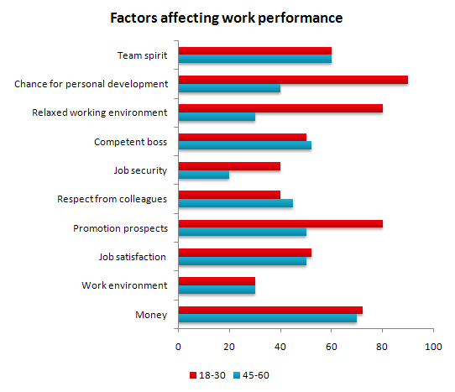

Sample Task 2
Write a passage to introduce the Chinese Moon Festival to foreigners. You should write about 600 words.

